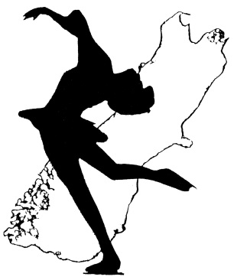
South Island Ice Skating Sub-Association

APPLICATION FOR VIDEO PERMIT

The South Island Ice Skating Sub-Association (SIISSA) retains the rights for any video recording of the South Island Ice Figure Skating Championships. Spectators may apply in writing to use video equipment to record portions of the event for their private use only. The use of flash photography or video flood lights is not permitted.

Video Permits are only to be provided to those people who make application on this official SIISSA form. A video area will be provided by the Organising Committee. Only people who have a video permit may video and the videoing is to be of their own skater/team only. If they wish to video other skaters/teams, then they need the written permission of the skaters concerned, or in the case of minors, their parents/guardians.

I hereby apply for permission to video the following skater(s)/team(s) of the 2018 South Island Ice Figure Skating Championships:

I understand that I may only use portable video equipment, and may only record my own skater/team for which this permit has been approved.

I attached written permission from the following skater/parents/guardian to video their programmes:

If requested, I agree to provide the SIISSA with a copy of all or any of the recordings I have made of the Championships.

Name: ……………………..…………………………………………. Signed: ……………………………………………………….
Email Address: ……………………..……………………………………………………………………………………..…………….

VIDEO PERMIT
Permission is hereby granted to: ………………………………………………………………...……………………………….…..

to video the following skaters/teams at the 2018 South Island Ice Figure Skating Championships:

Signed on behalf of the Organising Committee
Date
THIS PERMIT MUST PRESENTED TO GAIN ENTRY TO THE VIDEO AREA

